Please, refer to the Author Guidelines (https://journals.seedmedicalpublishers.com/index.php/cmi/about/submissions#authorGuidelines)
This template should be used as a guide for formatting your manuscript.

Title

Word count for case reports: not less than 1800 words (excluding abstract and references)

Key Words
3 to 5 words or phrases (possibly MeSH terms, see https://meshb.nlm.nih.gov/search).

Example
Hepatitis B, Chronic; Hepatitis B virus; Prevalence; Risk Factors

Abstract
Structured or unstructured abstract is accepted (about 600-1000 characters). It should begin with an introduction on the pathology and go on with a brief description of the main clinical findings that in this patient led to the diagnosis, the treatment used, and the outcomes.

Why we describe this case
2-3 sentences highlighting why this article is useful for a clinician (e.g. rare disease, pathology frequently misdiagnosed, presence of several comorbidities, particular clinical picture)

Introduction
In every section, references should appear as a number i.e., [1,2] in the order that they occur in the text or in Tables and Figures.

The diagnosed pathology should be described briefly:
- Epidemiology
- Pathophysiology
- Diagnosis
- Treatment

Case Presentation
The following points should be described:
- Patient information (be sure to guarantee patient’s anonymization)
- Clinical findings
- Timeline
- Diagnostic assessment
- Therapeutic intervention
- Follow-up and outcomes

Tables should be numbered consecutively in Roman numerals according to the order in which they have been first cited in the text. Captions should include a brief description. Define in the legend all abbreviations that are used in the table/box. Tables and boxes can be incorporated into the body of the manuscript, preferably in either Word or Excel format. See the following example about blood tests

Parameter | Detected level | Normal range
WBC (n/l) | 2600 | 4000-10,000
Neutrophils (n/l) | 1900 | 1500-8000
Lymphocytes (n/l) | 750 | 1000-4000
PLTs (n/l) | 93,000 | 140,000-450,000
ANA | 1/160 | < 1/80
Anti-dsDNA (UI/l) | 92 | < 10
Table I. Laboratory analyses performed in 2012
ANA = antinuclear antibodies; Anti-dsDNA = anti double strand-DNA; PLTs = platelets; WBC = White Blood Cells

Figures should be numbered consecutively according to the order in which they have been first cited in the text. In the caption, a brief description, including also the significance of arrows should be reported. Detailed diagnostic reports of CT scan, X-rays, and imaging in general should be reported here (just brief descriptions in the text). Each abbreviation should be explained after the figure legend in alphabetical order (see example on Tables).

See the following example

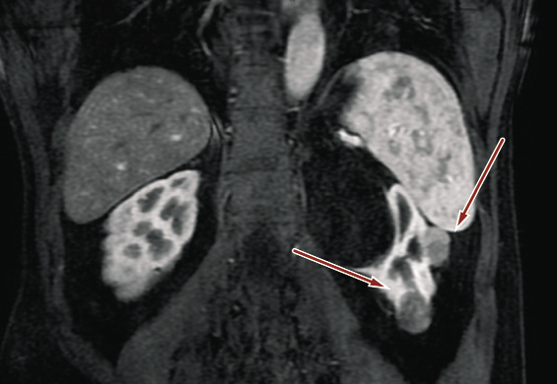
Figure 1. Intravenous contrast abdominal computed tomography showing two contrast-enhancing solid lesions 20 mm in diameter (red arrow – the upper one) and 25 mm in diameter (red arrow – the lower) in the left kidney

What should the clinician ask him/herself or the patient? (optional, but highly suggested)
- A bulleted list (3-10 items) reporting the questions that should be asked facing such a patient

Discussion
Discuss the main features of this case report, highlighting diagnostic difficulties and peculiarities. Eventually cite the most updated guidelines and compare with similar case reports published in the literature.

Conclusion
Optional. Emphasize the main take-home messages of the case report.

Key points
- A bulleted list (3-10 items) reporting the main take-home messages of the case report

Diagnostic-therapeutic algorithm
Optional, but highly suggested. To be reported as a flow-chart

Consent to publication
The consent to publication must be obtained from the patient described in the article (or parent, guardian, or relative in case of underage, mentally or physically impaired, or deceased patient). The signed form should neither be sent to the CMI journal manager, nor be uploaded in the submission platform. CMI journal does not collect these forms, but they must be held by the treating institution.
In this section, please write “The consent to publication was obtained from the patient (parent, guardian, or relative) here described”.
In fact, the consent to publication must be obtained from the patient described in the article (or parent, guardian, or relative in case of underage, mentally or physically impaired, or deceased patient). The signed form should neither be sent to the CMI journal manager, nor be uploaded in the submission platform. CMI journal does not collect these forms, but they must be held by the treating institution.
You may use our form, available in English and Italian. Otherwise, your institutional consent form may be used, if all the required elements are present (see our form).

References
Should be numerically listed in the reference section in the order that they occur in the text or in Tables and Figures. Should appear as a number i.e., [1,2] in the text

Examples

[example for journal article]

- Hostler D, Everson-Stewart S, Rea TD, et al; Resuscitation Outcomes Consortium Investigators. Effect of real-time feedback during cardiopulmonary resuscitation outside hospital: prospective, cluster-randomised trial. BMJ 2011; 342: d512; http://dx.doi.org/ 10.1136/bmj.d512
- Houssami N, Abraham LA, Miglioretti DL, et al. Accuracy and outcomes of screening mammography in women with a personal history of early-stage breast cancer. JAMA 2011; 305: 790-9; http://dx.doi.org/ 10.1001/jama.2011.188

[example for chapter of a book]

- Lunet N. Meta-analysis of observational studies. In: La Torre G (ed). Applied Epidemiology and Biostatistics. Torino: SEEd Medical Publishers, 2010

[example for poster presentation]

- Smith AB, Jones CD. Recent progress in the pharmacotherapy of diseases of the lower urinary tract. Presented at: 13th International Symposium on Medicinal Chemistry. Atlanta, GA, USA, 28 November-2 December 1994

[example for website]
- Merriam-Webster’s Collegiate Dictionary. 11th ed. Springfield, MA: Merriam-Webster Inc, 2003. Available at: http://ww.m-w.com/dictionary.htm (last accessed November 2012)

- National Institute for Health and Clinical Excellence. Antisocial personality disorder. London: NICE, 2009. Available at: http://guidance.nice.org.uk/CG77/PublicInfo/pdf/English (last accessed October 2012)

