Please, refer to the Author Guidelines (https://journals.edizioniseed.it/index.php/cmi/about/submissions#authorGuidelines)
This template should be used as a guide for formatting your manuscript.

Title

Key Words
3 to 5 words or phrases (possibly MeSH terms, see https://meshb.nlm.nih.gov/search).

Example
Hepatitis B, Chronic; Hepatitis B virus; Prevalence; Risk Factors

Abstract
Structured or unstructured abstract is accepted (about 600-1000 characters)

Introduction
In every section, references should appear as a number i.e., [1,2] in the order that they occur in the text or in Tables and Figures.

The pathology/pathologies covered by the article should be described briefly:
- Epidemiology
- Pathophysiology
- Diagnosis
- Treatment

If a particular treatment is the topic of the article, it should be described thoroughly, mentioning also effectiveness, most common side effects, and main comparators.
The purpose of the article should be described at the end of the introduction.

The structure of the article is free: headings and subheadings should be written according to the Authors’ judgement.

Heading 1

Subheading 1.1

Subheading 1.2

Heading 2

Subheading 2.1

Subheading 2.2

Subheading 2.3
Etc..

Tables should be numbered consecutively in Roman numerals according to the order in which they have been first cited in the text. Captions should include a brief description. Define in the legend all abbreviations that are used in the table/box. Tables and boxes can be incorporated into the body of the manuscript, preferably in either Word or Excel format. See the following example

Baseline features | Score
Active cancer* | 3
Previous VTE (with the exclusion of superficial vein thrombosis) | 3
Reduced mobility† | 3
Already known thrombophilic condition‡ | 3
Recent (≤ 1 month) trauma and/or surgery | 2
Elderly age (≥ 70 years) | 1
Heart and/or respiratory failure | 1
Acute myocardial infarction or ischemic stroke | 1
Acute infection and/or rheumatologic disorder | 1
Obesity (BMI ≥ 30) | 1
Ongoing hormonal treatment | 1
Table I. Risk assessment model (high risk of VTE: ≥4) of the Padua Prediction Score [10]
BMI = body mass index; VTE = venous thromboembolism
*Patients with local or distant metastases and/or in whom chemotherapy or radiotherapy had been performed in the previous 6 months.
†Bedrest with bathroom privileges (either due to patient’s limitations or on physicians order) for at least 3 days.
‡Carriage of defects of antithrombin, protein C or S, factor V Leiden, G20210A prothrombin mutation, antiphospholipid syndrome.

Figures should be numbered consecutively according to the order in which they have been first cited in the text. In the caption, a brief description, including also the significance of arrows should be reported. Each abbreviation should be explained after the figure legend in alphabetical order (see example on Tables).

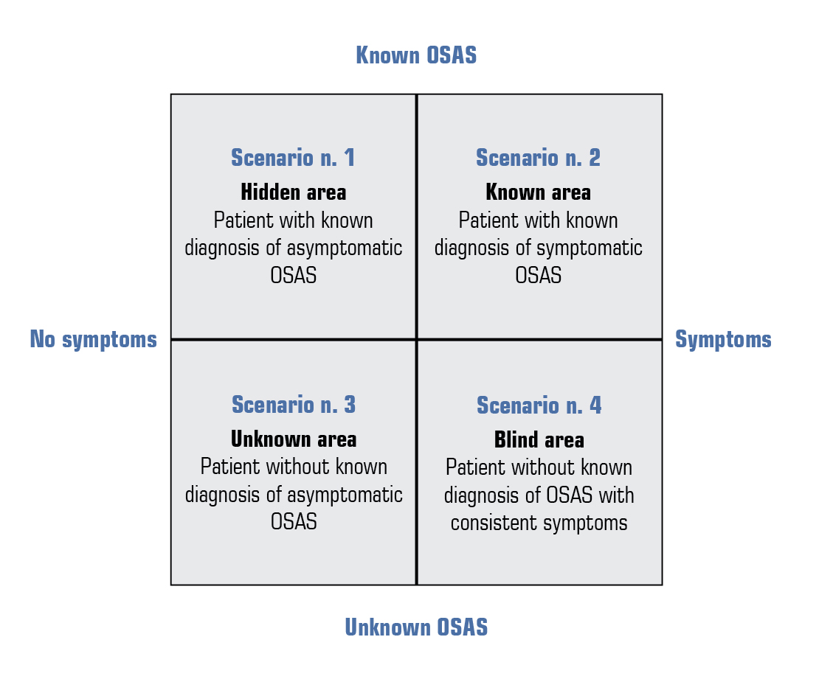

Figure 1. A brief description, including also the significance of arrows.
Each abbreviation should be explained after the figure legend in alphabetical order.
OSAS = obstructive sleep apnea syndrome

Conclusion
Optional. Emphasize the main take-home messages of the case report.

Key points
- A bulleted list (3-10 items) reporting the main take-home messages of the case report

Diagnostic-therapeutic algorithm
Optional, but highly suggested. To be reported as a flow-chart

References
Should be numerically listed in the reference section in the order that they occur in the text or in Tables and Figures. Should appear as a number i.e., [1,2] in the text

Examples

[example for journal article]

- Hostler D, Everson-Stewart S, Rea TD, et al; Resuscitation Outcomes Consortium Investigators. Effect of real-time feedback during cardiopulmonary resuscitation outside hospital: prospective, cluster-randomised trial. BMJ 2011; 342: d512; http://dx.doi.org/ 10.1136/bmj.d512
- Houssami N, Abraham LA, Miglioretti DL, et al. Accuracy and outcomes of screening mammography in women with a personal history of early-stage breast cancer. JAMA 2011; 305: 790-9; http://dx.doi.org/ 10.1001/jama.2011.188

[example for chapter of a book]

- Lunet N. Meta-analysis of observational studies. In: La Torre G (ed). Applied Epidemiology and Biostatistics. Torino: SEEd Medical Publishers, 2010

[example for poster presentation]

- Smith AB, Jones CD. Recent progress in the pharmacotherapy of diseases of the lower urinary tract. Presented at: 13th International Symposium on Medicinal Chemistry. Atlanta, GA, USA, 28 November-2 December 1994

[example for website]
- Merriam-Webster’s Collegiate Dictionary. 11th ed. Springfield, MA: Merriam-Webster Inc, 2003. Available at: http://ww.m-w.com/dictionary.htm (last accessed November 2012)

- National Institute for Health and Clinical Excellence. Antisocial personality disorder. London: NICE, 2009. Available at: http://guidance.nice.org.uk/CG77/PublicInfo/pdf/English (last accessed October 2012)

